Assessment Portfolio
Blue Valley East HS Bands
Mr. Jacob Wright

Assessment Tool 1: Private Lessons with Band Director(s)—Checklist
- Private lessons are a way to give individualized attention to the students, assessing not only what they have already learned, but also what they still need to learn. Let’s take John (not a real student of mine), who is learning the flute and is learning to put the instrument together and make a sound. In a one-on-one lesson, I can assess John’s current level of knowledge, give him an individualized study routine (practice routine) and then at our next meeting, assess John’s learning again to see quantifiable growth.

- These lessons would be implemented in the following way:
  - Students are required to have two (2) lessons per semester (one to assess current knowledge, the second to assess growth).
  - The director would assign material addressed, unless the student brings his or her own material. I.e. solo repertoire, fundamental skills, music addressed in ensembles, etc.
  - No fee would be charged to the students; most private instructors charge a fee. However, being an individualized assessment the students will not pay.

- With these lessons being personalized for the students the validity and reliability will be established through student growth in knowledge and skill.
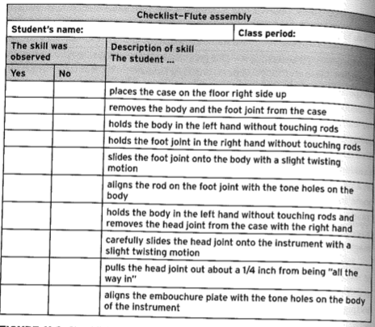

Assessment Tool 2: History Test—Paper/Pencil
- In K-12 music, written tests are not a common occurrence. However, at the high school level, the students’ playing abilities are at a level to where we can begin to address “complete musician” this goes beyond playing the music and addresses the history, context, and theory of the music. A written history test would not be very long and would only be related to the music being learned and performed. This presents the students with a deeper knowledge of the music and takes the performance beyond notes and rhythms.

- A test would be implemented in the following way:
  - Students would be given the study material one week before the exam.
    - Dates/Composers
    - Historical Context
    - Recognition of piece aurally (listening identification)
  - The exam would take place during class time, will not be a long exam. Should very easily take 20 minutes.

- While written exams can be frustrating both for students and teachers; they are a way to gauge retained knowledge through lecture and study. The second part of this equation is to adjust teaching if needed.

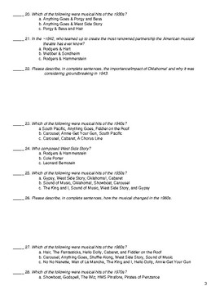

Assessment Tool 3: Theory Test—Paper/Pencil
- In K-12 music, written tests are not a common occurrence. However, at the high school level, the students’ playing abilities are at a level to where we can begin to address “complete musician” this goes beyond playing the music and addresses the history, context, and theory of the music. A written history test would not be very long and would only be related to the music being learned and performed. This presents the students with a deeper knowledge of the music and takes the performance beyond notes and rhythms.

- A test would be implemented in the following way:
  - Students would be given the study material one week before the exam.
    - Key Center(s)
    - Form
    - Score identification (a short snippet of the score would be shown for the students to recognize and name—easy part of the score, i.e. the first 8 measures of a piece we are playing.)
  - The exam would take place during class time, will not be a long exam. Should very easily take 20 minutes.

- While written exams can be frustrating both for students and teachers; they are a way to gauge retained knowledge through lecture and study. The second part of this equation is to adjust teaching if needed.
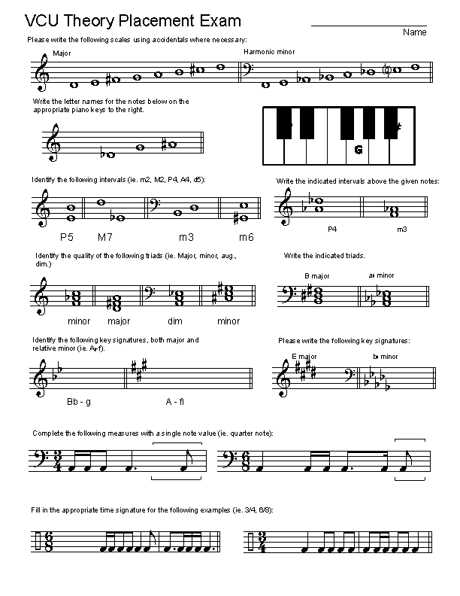

Assessment Tool 4: Performances—Summative
- In any music classroom, performance is the major form of assessment. Just as a midterm exam is in any other class, performances are the musicians “midterms” it’s the culmination and presentation of all the learned and retained knowledge throughout the rehearsal process. The over-simplification of it is “how good does the ensemble sound”.
- Performances will occur twice a semester, (Fall, Winter, Contest, Spring)
  - Four–Five pieces per concert depending on prep time and requirements for state contest.
  - Students will be assessed on stage presence, musical performance, and preparation during the rehearsal period.
- The validity and reliability of this form of assessment comes from the quality of performance and growth of the ensemble through the academic year. Just like the way the football or volleyball team would be assessed on their performance and season record, performing ensembles are assessed in the same fashion.

Assessment Tool 5: Discussion Based Assessment—Verbal Assessment
- In some smaller ensembles like jazz ensemble or chamber choir, discussions between members of the ensemble and/or the director are just as helpful. In a jazz ensemble, articulation length is (usually) determined by the lead trumpet and lead alto. Also depending on what piece is being played, that length will vary within the same style. These short discussions allow the director to assess the students’ knowledge of the pieces and styles they are playing.
- These discussions will happen organically, as long as they are on topic, no real adjustments or rubrics are needed.

Assessment Tool 6: Rehearsal—AOL
- Rehearsal is the other major form of assessment in music classes. Each day is approached as the assessment of the previous class’ work and “homework” (practice time on the students’ part). The first rehearsal of a concert block begins with sight-reading, which is the introduction to the content, much like a new unit being introduced in a history class; the first day is an introduction and overview of the content.
- Rehearsals will be implemented in the following way:
  - Class schedule (MWF or TUF) on a block schedule
- The validity and reliability of this assessment tool stems from the idea that consistent, correct work, yields positive results. Throughout the rehearsal sequence I will assess the students’ growth and adjust rehearsal techniques and pieces/parts of pieces addressed accordingly. Just as an English teacher would address certain vocabulary words more intensively after testing over all of them.

Teacher(s): Mr. Jacob Wright Grade Level: High School Date Taught: 3/8/2019

Lesson Title: “Recordame” Subject: Jazz Ensemble I Approx. Time: 45 minutes.

Lesson Objective | Students will be able to play all correct notes and rhythms in the written (non-improvised) portion of the big band tune Splanky.  Students will demonstrate their comprehension of the style of the tune through enactive listening and discussion.
New & Familiar Vocabulary | Bossa Nova, Articulation, Style, Dynamics, Syncopation, Improvisation, minor scale
Assessment/Criteria | Correct notes and rhythms are the criteria for this lessons assessment of student learning.
Materials/Resources | Score and Parts  Metronome  Recordings

Warm Up/ Listening | 10 min. | - As the students enter the classroom, a recording of the tune Splanky will be played for the students to listen to. (Passive listening)  - Students will have 2 minutes to warm up on their own.  - The recording will be played a second time, the students will follow along in their own parts as they listen and come up with 3 details to discuss about the style of the piece. (Enactive listening)  - A short (approx. 4 minute) discussion will be had as an ensemble, fostered but not led by the director. (Student led discussion)
Rehearsal | 30 min. | - Sight-read the chart top to bottom. (Start/Stop as needed)  - Address any incorrect notes/rhythms. (Ensemble will then be given 1 minute to find and address any personal issues with notes and rhythms)  - Play “trouble spots” that were just practiced, add phrases/sections on either side of each spot to put them in context.  - Allow for questions and feedback from the class to each other. (Guided discussion)  - Full run of the tune at the end, actively listening for any positive/negative things that should be addressed.
Closure | 5 min. | - Address any final questions/points of concert in the music.  - “Recordings will be sent to you all via email”  - Pack up and tear down rehearsal space.

**This lesson and rehearsal would be the first or second meeting of the concert block and so sight-reading and proper setup for the later rehearsals are the primary objectives for this lesson.**
Assessment Tool 7: Sectionals and Reports—Summative
- This assessment tool allows the students to take complete ownership of their learning and assess themselves and peers. Just as each student may need to study a bit differently than each other to do well on a history exam, sectionals allow each instrument family to work on what is difficult in that piece on those parts. What is difficult for the clarinets may not be difficult for the trombones because they have something completely different. The sectional report allows me as the ensemble director to A) know what the students worked on, B) gauge their growth, and C) implement their needs and work into the large ensemble rehearsal setting.

- Sectionals will be implemented in the following way:
  - Each section will be required to have two (2) sectionals each concert block. One will occur during regular class time, the band directors will walk between sectionals to facilitate and monitor as needed.
  - The second will be on the students’ own time (30 minutes to an hour). If they need access to the band room (percussion) the band director(s) will be there to give them access.
  - Sectional reports (bullet points) will be made by each section and given to the director.

- The validity and reliability for this assessment tool will stem from the growth and personal ownership each student takes in their own success. As the band director I can spoon-feed the ensemble all the information, but they will not retain very much of it, and being “babied” is annoying to the students. Giving students ownership of their own work is very important.

Sectional Report

Section: _________________________________________

Piece(s): _________________________________________

Segments: ________________________________________

Notes: __________________________________________________________________________________________________________________________________________________________________________________________________________________________________________
Assessment Tool 8: SmartMusic Playing Test—Rubric
- SmartMusic is a program that contains recordings and sheet music of thousands of pieces of music that students can play along to. It is also possible to record yourself playing into the program and it will show you what notes and rhythms you missed, and your timing within rhythms. This is a great way for the teacher to assign work, have it recorded, and the students will send it back. It does, in a way, force students to practice, however it keeps everyone accountable.

- SmartMusic will be implemented in the following way:
  - The band director will give students access to the program.
  - Depending on instrument, the student will record himself or herself playing with the music. (Multiple takes can be done and practice can be done as well).
  - Recordings will be sent to the band director(s) with a grade on a scale from 0-100.
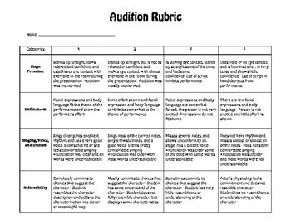
- The validity of this assessment tool comes from the quantitative data that comes from the recordings in the program. It also shows the student what parts of the music they should isolate in their practice in order to perform to the best of their ability.

