

**WORKING WITH STAKEHOLDERS**

EDCEP 525 Interpersonal Relations-Mrs. LeMay

*Contributions: Dr. Jessica Lane KSU*



**REVIEW**

Take knowledge of yourself, Conflict Resolution style(s) & apply to today’s lesson

REVIEW OF KEY WORDS:

it, we, you what, how



**Parent - Teacher Conferences**

**Activity:**

Take a notecard and on the front side list the **“Dream”** Parent- Teacher Conference. What would it look like? What would happen?

On the backside, describe what the **“Nightmare”** Parent- Teacher Conference would look like. What would happen, what’s your greatest fear?



**More Alike Than Different**

**Activity:**

**T-Chart: Parents and Teachers**

What do you believe are the goals of parents when they attend parent-teacher conferences?

What do you believe are the goals of teachers at parent-teacher conferences?



**Working with Parents**

Initiate Communication

Find MULTIPLE avenues for communication Constant communication; don’t blind side

Acknowledge and appreciate parent participation and feedback, even if minimal



**TOP 10 Techniques**

**1. Begin contact on a positive note.**

**6. Treat communication as**

**confidential.**

1. **Analyze student’s immediate**

**needs. 7. Consider the WHOLE student - strengths and weaknesses.**

1. **Consider communication to be a**

**two-way exchange. 8. Have concrete examples available.**

1. **Tell the truth, but be diplomatic.**

**9. Follow-up on any decisions**

1. **LISTEN to what the parents have made. to say.**

**10. End communication on a positive note.**

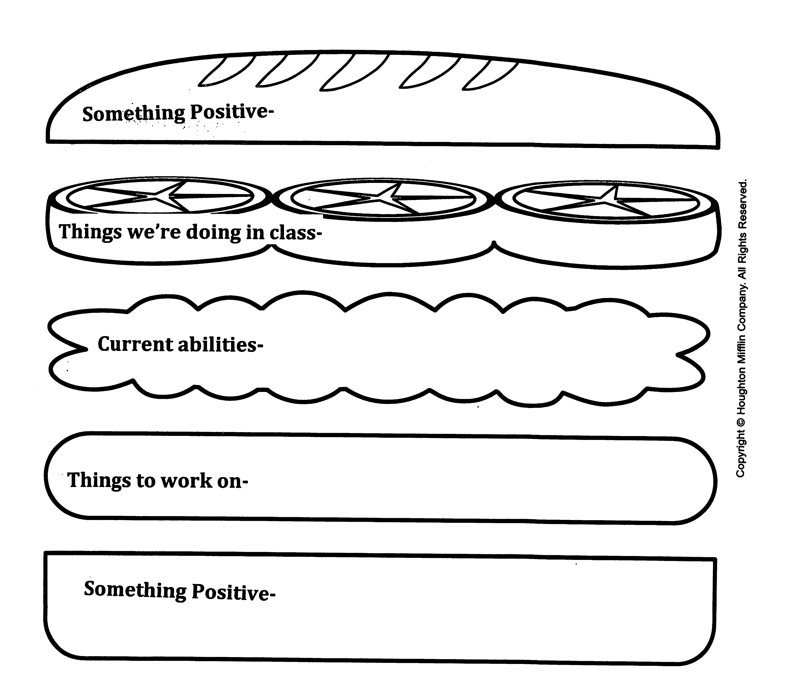

**Feedback Sandwich**

Something Positive

What we’re doing in class Current Abilities

Things to work on Something Positive

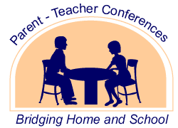

**Types of Parent-Teacher Conferences**

Beginning of School meetings/ Introduction

Academic Progress Behavior Conference Parent Requested



**5 Must Answer Questions:**

1. What **skills and knowledge** will my child be expected to master in your class?
2. What kind of information will you use to **assess my child’s academic progress**? How do you **assign grades**?
3. What can I do to **stay actively involved** in my child’s academic progress?
4. How do you **accommodate differences** in learning?
5. How do you plan to **prepare my child for the next** grade **level** (or life beyond HS)?



**STAKEHOLDER ROLE PLAYS**

This activity was designed to provide:

A safe environment to learn about your handling of situations/ triggers

Opportunity to explore how you might handle/better handle situations in real-life

Identify a variety of situations and scenarios



**PRACTICE**

**Activity: Beginning of School Year**

With the person sitting across from you, you will conduct a brief 3 minute “getting to know you conference”. Utilize the steps, tips, & key questions provided. One will serve as the parent, the other the teacher. Be sure to utilize your honorific, greet the parent, & shake hands. :)



**ROLE PLAY**

**Activity:**

With your team, you will be given a vignette. Your job is to role play the scenario given for the time given. Each of you will have the opportunity to serve as the teacher, another key stakeholder and the audience for feedback.

Upon completion, the group will discuss positives & provide feedback.

Please TRY to make this authentic and a SAFE place to practice this meaningful activity.



**Additional Tips /Information**

**Working with Administrators:**

communication is essential

frequency dependent upon circumstances, admin. leadership style, & your own personality

“Golden Rule” onto administrators

Keep abreast to issues or disciplinary measures, stick to facts



**Additional Tips/Information**

Working with Colleagues:

**Professional Level**

**Personal Level**

keep informed of student

needs

can provide strong sense of

support, guidance, & information

keep as positive as possible

learn everyone’s name &

something about them

failure to communicate can

lead to long-lasting misunderstandings

avoid heated topics (politics,

religion, etc.)

seek job related help when

needed



**Additional Tips/Information**

**Communicating with Angry People**

remain calm & stay objective

move to a more private venue if confronted in a public place allow the person to vent within reason

validate person’s concern by restating in your own words offer a sincere apology if called for

find a point of common agreement / arrive at a mutually acceptable solution end the discussion cordially